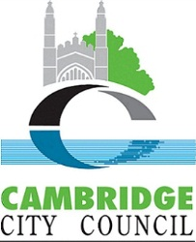
Environmental Improvement Programme (EIP)
2023 Year Project Ideas
Proposal/ideas are open from 21 September 2022, the earlier you submit them the sooner we can post them on Citizenlab and once on their the greater the chance others may support. Submission ideas are unlikely to be accepted following 28 October 2022.

First Name | PIERO

Surname | D’ANGELICO

Email Address (not to be shared with public) so we can contact you for more project details if your idea is supported | millroadtraders@gmail.com

Location of suggested Environmental Improvement - Street/Greenspace name or nearest postcode | Ditchburn Gardens, Ditchburn Place, Mill Road Cambridge

Title - What: Issue/Problem/Improvement – please give a title to idea and what your idea is likely to achieve:
Cambridge Gateway from India
Re-use and public display of stones originally forming an internal shrine for the Hindu community, now being repurposed with that community’s approval, as a public outdoor feature for all communities. Our proposed re-erection of the stonework in the form of a gateway in the public gardens at Ditchburn Place will give it new life as a lasting public monument and symbol of the Hindu community, to be shared by the many different communities of Mill Road, and as a visible expression of what has been described as the most diverse street in England.

The magnificent stonework which will form the gateway was commissioned by Cambridge’s Hindu Community as a shrine in the Bharat Bhavan (the former Mill Road Library). With the loss of the Hindu Shrine after 15 years, this unique piece of art would have been lost.

Description - How: Suggested Solution – please outline how you feel your objectives might be best met e.g., improve biodiversity on Joe Bloggs Street – Plant wildflower grasses on greenspace on corner outside number 1 Joe Bloggs Street and change grass cutting regime:
Thanks to crowdfunding from the whole community (“Hindus, Muslims, Christians, atheists”), the stonework was carefully dismantled, and salvaged by Mill Road Traders when the County Council repossessed the building. It is now being stored.

The stonework will be remodelled to be erected as a lasting monument, set in the public gardens and to be enjoyed by all, at Ditchburn Place on Mill Road, Cambridge. Ditchburn Place and its gardens are already a focal point during the Mill Road Winter Fair; the Gateway will provide a central focus for both the gardens and the Fair.

(Please see website link below for more details).

http://www.cambridgegatewayfromindia.co.uk/

Planning permission has been granted (ref 22/01132/FUL “Relocate and reconfigure the placement of Indian carved archway”).

Officers and the local community supported the proposal
(extract from delegated report below)
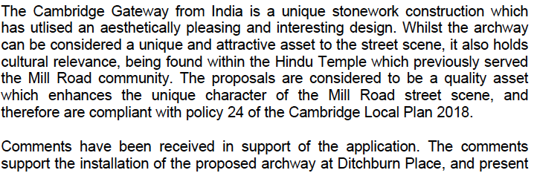

This grant application is being made for £10,000 towards the costs of preparing the stones, erecting the Gateway, and associated landscaping. We are also making an application to the National Lottery Community Fund, and we will shortly be embarking on a major public fundraising effort. We have a fundraising banner being prepared for display on the site.

Outcomes - Why: Joe Bloggs Street is part of an important Local Nature network corridor, it will help with health and wellbeing of local people, improve the environment, contribute towards secure nature species for the future.
This is a project by and for the whole local community (as shown by the range of support for the crowdfunding). It is an opportunity for us all to work together, to build something beautiful.

This majestic stone archway will be enjoyed for generations to come. This will bring about community diversity and cohesion, embracing the Hindu community within the area and among local communities; whilst housing the stones on Mill Road, giving them a second chance, and honouring the efforts of those that originally carved, commissioned, and shipped them.

This grant application relates to the re-erection of the stones as the Gateway from India. Our further plans (not part of this grant application, but listed here to show our full aims) include:

- working with Anglia Ruskin University students on ideas for future explanation / interpretation of the Gateway, and the history and significance of the stones;
- We hope to provide 4 seats (also not part of this grant application) to be situated near to the Gateway; our aim is for each to celebrate someone local who has made a great contribution to the Mill Road area. Our candidates (all champions of the community) so far are the late Suzy Oakes (founder of and inspiration for the Mill Road Winter Fair, who helped to set up the community website mill-road.com, was active with the Friends of Mill Road Cemetery, and founded the Suzy Oakes Trust which supports Mill Road community activities), the late Allan Brigham MBE (street sweeper, local historian, tour leader, and enthusiast for the Mill Road area), and the late Syed Abdul Hekim (fondly known as Bason Miah), who introduced Cambridge’s first ever tandoori oven, was a great supporter of the local Bangladeshi community, and is remembered as the man with the kindest smile on Mill Road.
Who: Please outline who or which Group is proposing the project or whether local Councillors support?
The Mill Road Traders’ Association took the initiative to salvage the stones, and has developed the project, with the support of donations from the whole community, from Hindus, Muslims, Christians, atheists, and all accompanied by supportive messages.

The local community and Councillors are supportive of this project. The initial approach was made in discussion with Cllr Lewis Herbert when Leader of the City Council, supported by City and County ward councillors. There was 80% clear support for the project in a Council consultation exercise.

Cambridgeshire County Council has been very supportive in transferring the ownership of the stone archway to the Mill Road Traders’ Association.

Cambridge City Council has granted planning permission for the new home for the stone archway on Mill Road.

Proposed Budget - Not compulsory - But may outline items required, and possibly an approximate cost of these giving an approx. budget requirement - note Officers with experience may add in estimate costs or change any costs inputted based on experience of delivering projects.
Spend to date
Purchase and transport of stones 6759.50
Storage to date 1930.35
Design /Planning / Professional Fees 2454.00
Fundraising 2084.09
Total spend to date (cash 4739.15, donations in kind 8488.79) 13227.94
Total in hand (cash 6800.60, donations in kind 7,000.00) 13800.60
Spend required
Preparation and construction (Hibbitts stonemasons) 28362.00
Foundation and pad stone (Hill) 6500.00
Landscaping 4500.00
Opening to public 500.00
Contingency 10% 3986.20
Total cost of remaining work 43848.20
Less total in hand 13800.60
Total remaining to be raised 30047.60

